Go to ec2

Launch instance

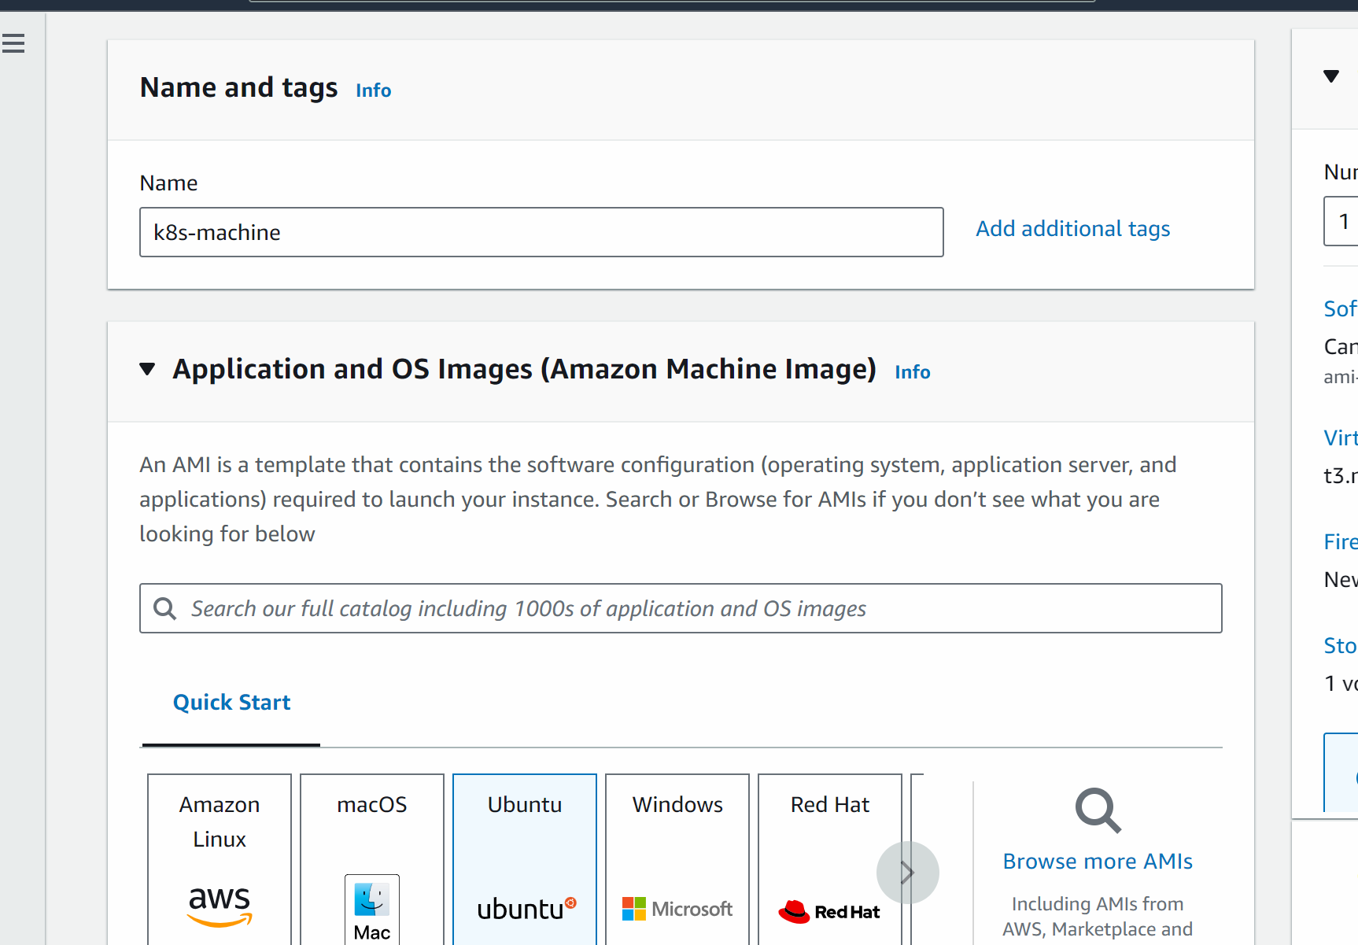

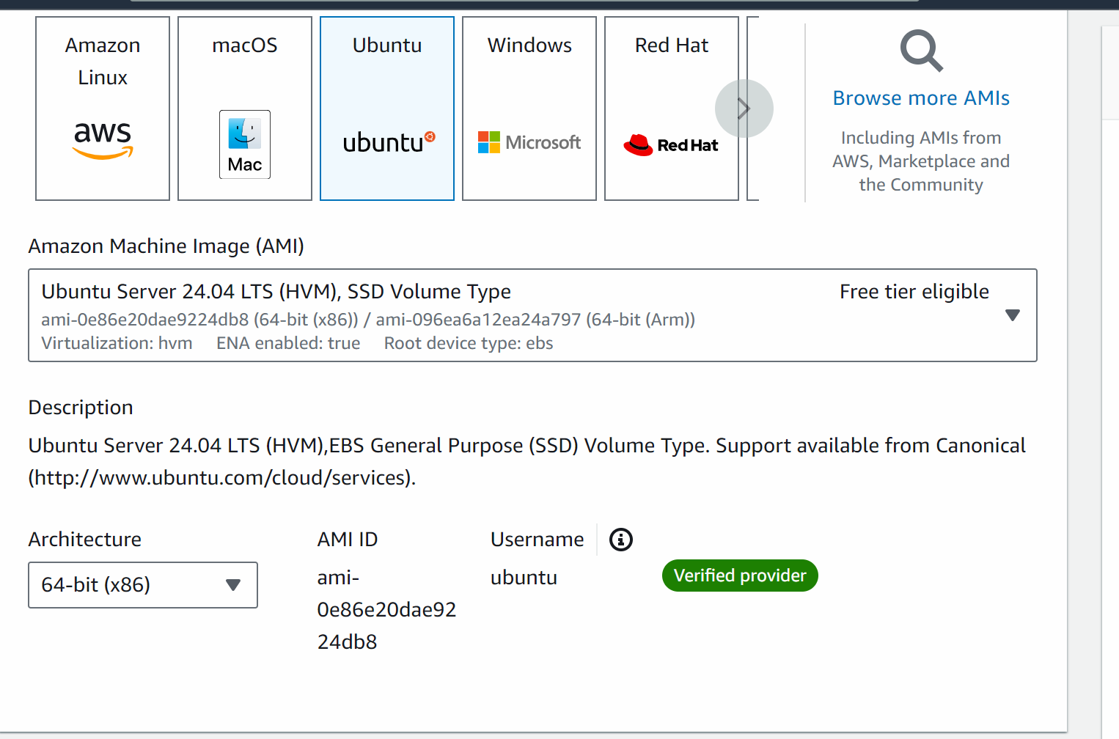

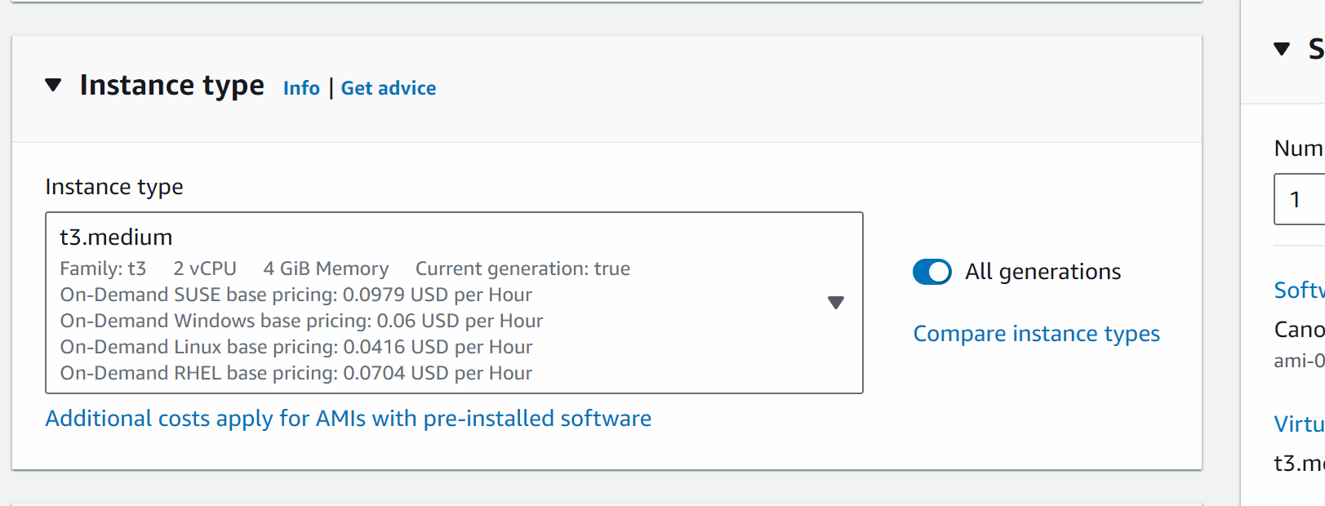

Create key pair

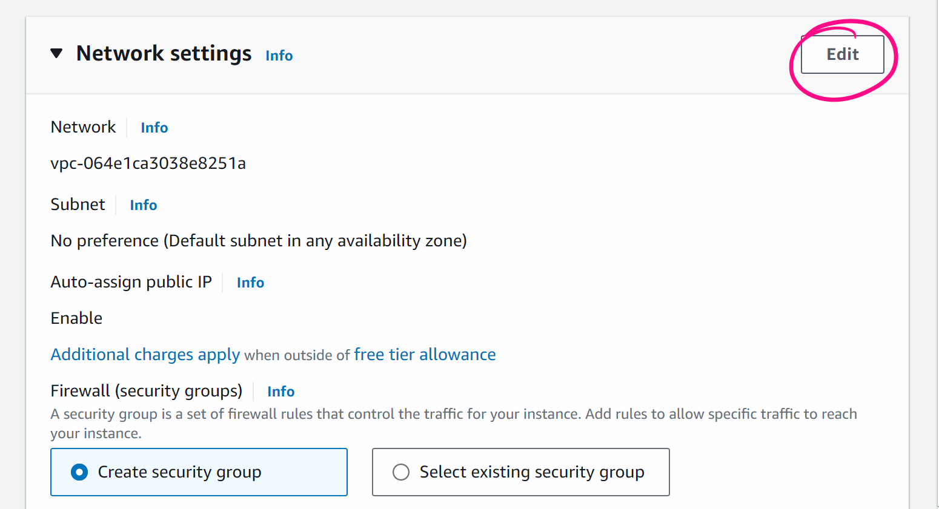

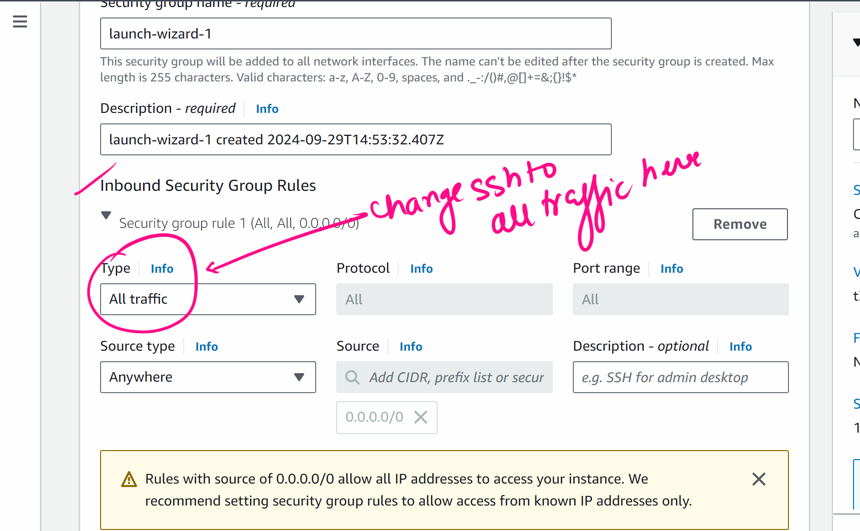

We need to create 3 machines

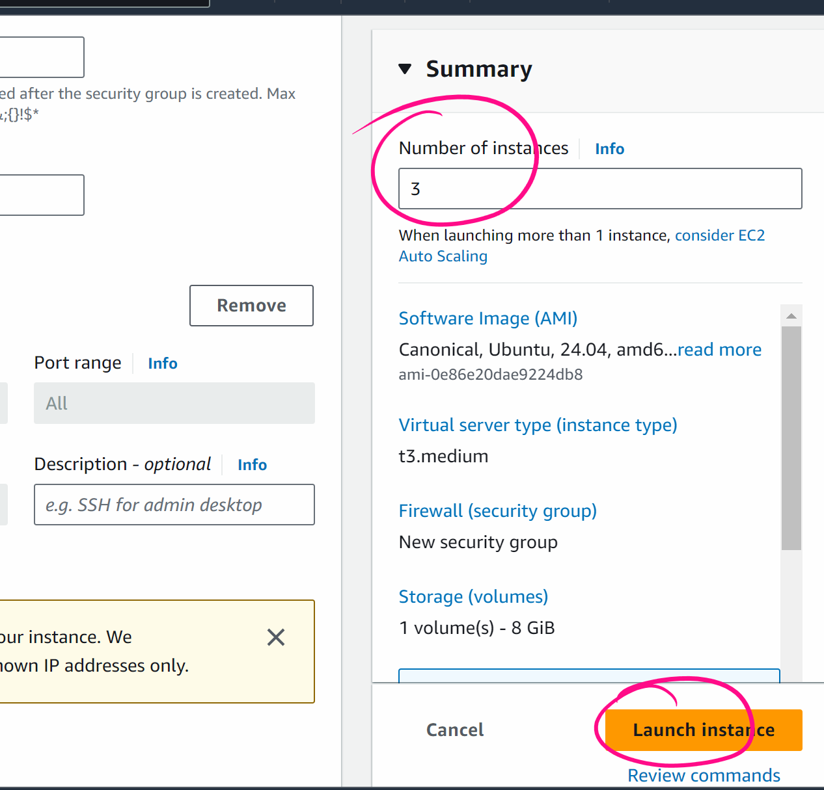

Rename the machines

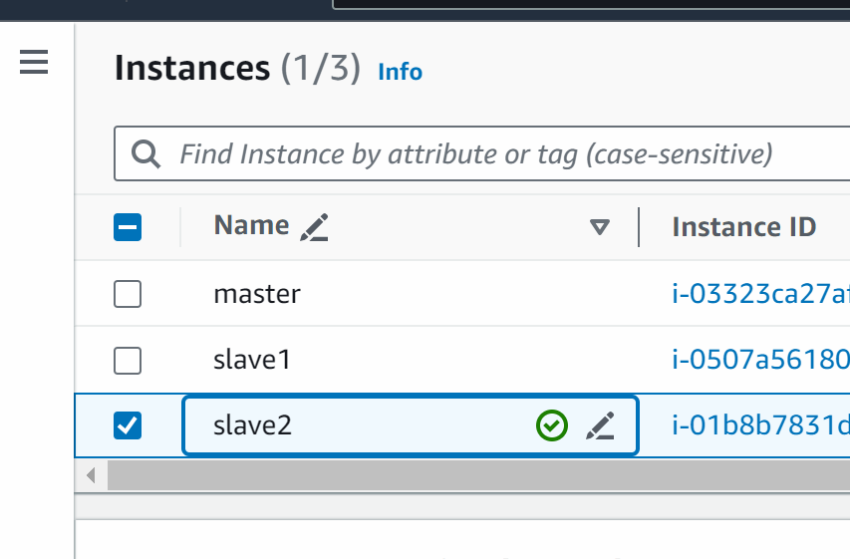

####
IN MASTER MACHINE:

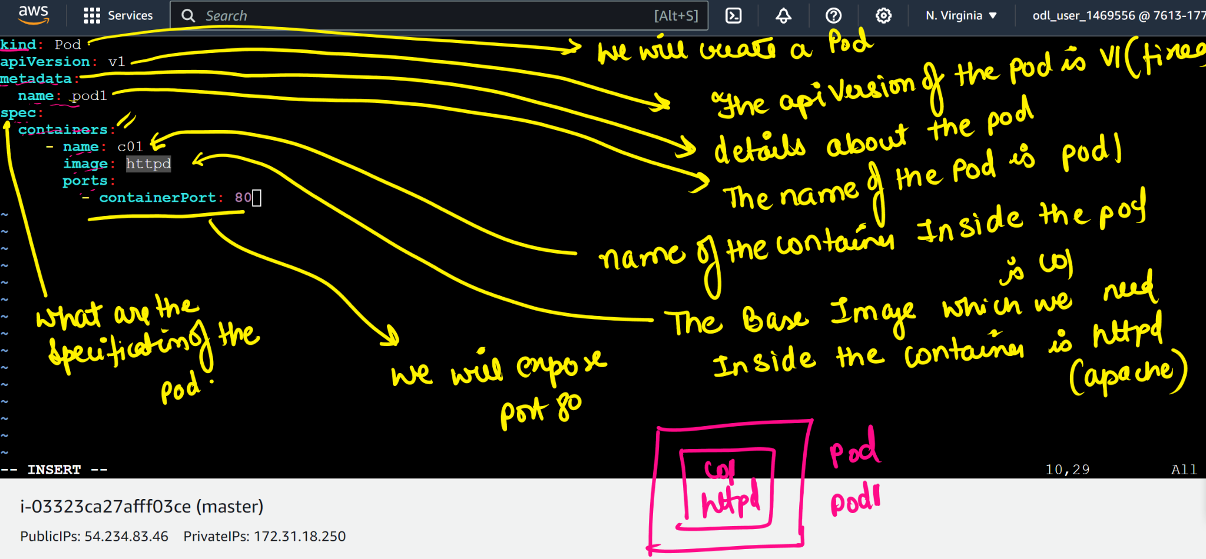
vi akshat.yml

kind: Pod
apiVersion: v1
metadata:
name: pod1
spec:
containers:
- name: c01
image: httpd
ports:
- containerPort: 80

Press esc :wq (save the quit the yaml file)

# kubectl apply -f akshat.yml

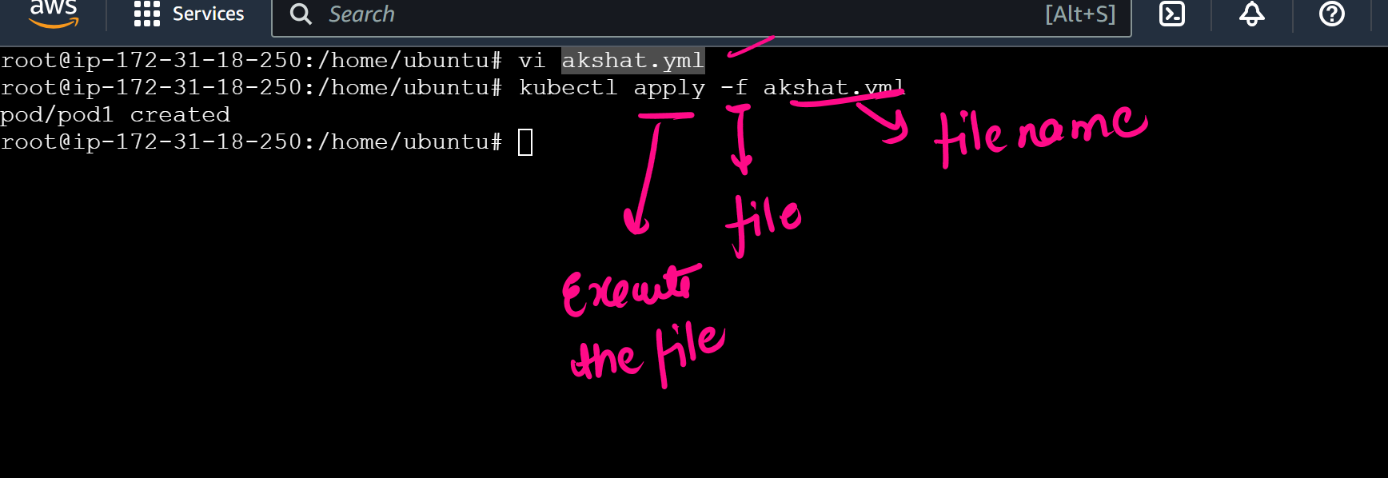

#kubectl get pods -o wide

